**VISVESVARAYA TECHNOLOGICAL UNIVERSITY**

"Jnana Sangama", Belagavi: 590 018

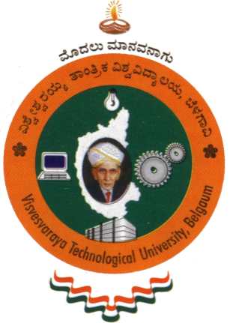

A Database Management Systems Mini Project report on

**“<Title of the project>”**

 Submitted in partial fulfillment of the requirement for the award of Degree of

**BACHELOR OF ENGINEERING**

**IN**

**COMPUTER SCIENCE AND ENGINEERING**

By

**NAME               USN**

Under the guidance of

**Prof. Ancy Thomas**

**Prof. Rashmi Kulkarni,**

**Prof. Chidananda T**



**DEPARTMENT OF COMPUTER SCIENCE & ENGINEERING**

**ACHARYA INSTITUTE OF TECHNOLOGY**

(Affiliated to Visvesvaraya Technological University, Belagavi)

**2020-2021**

**ACHARYA INSTITUTE OF TECHNOLOGY**

(Affiliated to Visvesvaraya Technological University, Belagavi)

Soladevanahalli, Bangalore – 560090

**DEPARTMENT OF COMPUTER SCIENCE AND ENGINEERING**



**Certificate**

Certified that the Database Management Systems mini project entitled **“<Title of Project>”** is a bonafide work carried out by **<Name> (USN)** of 5th semester in partial fulfillment for the award of degree of **Bachelor of Engineering in Computer Science & Engineering of the Visvesvaraya Technological University**, **Belagavi**, during the year **2020-2021.** It is certified that all corrections/ suggestions indicated for internal assessments have been incorporated in the Report deposited in the departmental library. The Mini Project report has been approved as it satisfies the academic requirements in respect of Mini Project work prescribed for the **Bachelor of Engineering Degree**.

**Signature of Guides                                                                                   Signature of H.O.D**

**Name of the examiners**                                       **Signature with date**

1.

2.

**ACKNOWLEDGEMENT**

I express my gratitude to our institution and management for providing us with good infrastructure, laboratory, facilities and inspiring staff whose gratitude was of immense help in completion of this seminar successfully.

I express my sincere gratitude to our principal, **Dr. Prakash M R** for providing required environment and valuable support for developing this mini project.

My sincere thanks to **Dr. Prashanth C M,** Head of the Department, Computer Science and Engineering, Acharya Institute of Technology for his valuable support and for rendering us resources for this mini project work.

I express my gratitude to **Prof. Ancy Thomas, Prof. Rashmi Kulkarni, Prof. Chidananda T,** Assistant Professors, Dept. Computer Science and Engineering, Acharya Institute of Technology who guided me with valuable suggestions in completing this mini-project at every stage.

My gratitude thanks should be rendered to many people who helped me in all possible ways.

**NAME**

**(**USN**)**